Guidelines for Setting up of Stand Alone Skill Centres

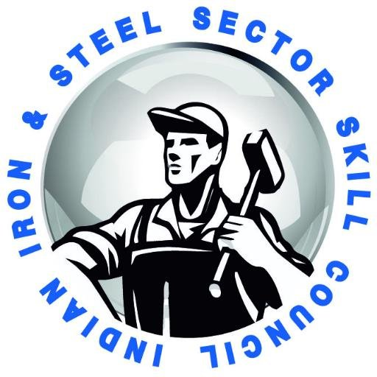
Indian Iron and Steel Sector Skill Council

Industry and Indian Iron and Steel Sector Skill (IISSSC) Overview

Steel Sector in India is nearly one and half century old and contributes significantly to the economic development of the country on the back of rising demand from infrastructure, construction, automobiles and a host of manufacturing and processing industries. Consumption of steel is important determinant of the socio economic development of a country. India ranks as 3rd largest crude steel producer and 3rd largest finished steel consumer in the world

Around 0.65-0.70 millon people are engaged in Iron and Steel Industry. As the installed steel capacity in the country reaches 300Mt in 2030-31 from the current level of 122Mt, the additional technical people required by the sector has been estimated to be 0.35 million numbers. The additional manpower demand at key international job markets (Gulf and Middle East countries, ASEAN countries, Bangladesh, Sri Lanka, Afghanistan, South Africa) for specific disciplines like Welding, Electricians (Electrical, Electronic & Instrumentation), Fitter, Machinist, Bearing Maintenance, Dumper Operator, Furnace Operator is likely to be another 0.1-0.15 million numbers in the minimum in the next 13 years.

The Indian Iron & Steel Sector Skill Council (IISSSC), is an industry (Iron & Steel,
Rerolling, Sponge Iron units, Ferro Alloys, Steel Construction and Welding) driven non-
profit company limited by Guarantee, registered under the Indian Companies Act,
1956 was set up in July 2013. The company is promoted by Institute for Steel Development & Growth (INSDAG) and Bengal Chambers of Commerce & Industry (BCCI) and mandated under National Skill Development Corporation (NSDC). The Governing Committee of the Council includes major Iron & Steel companies, Iron & Steel and related associations. IISSSC is committed to develop world class skilled manpower for the seamless supply of skilled workforce from the Iron &Steel Industry so that the industry can enhance productivity and profitability.

Background and context

IISSSC intends to establish visible and aspirational model training centres in every state of the country. The model training centres envisage to:
- Create benchmark institutions that demonstrate aspirational value for competency based skill development training.
- Focus on elements of quality, sustainability and connect with stakeholders in skills delivery process.

Under PMKVY 2.0. these centres will be exclusive, iconic and will be supporting IISSSC in conducting the Training of Trainer and Training of Assessors programs as well.

Project Proposal

Cluster of Districts

Cluster based approach is being followed by IISSSC for allocation of districts. Clustering has been done using the socio-economic, demographic and skills training coverage indicators to ensure that each cluster gets a mix of districts with varying levels of skill development activities. This is to ensure better geographic and demographic coverage across the country.

Infrastructure

- Branding

Each Stand Alone Centre will follow the PMKVY Branding and Communication Guidelines (2016-2020) follow by below link:
http://pmkvyofficial.org/App_Documents/News/PMKVY%20Branding%20and%20Communication%20Guidelines%2018th%20July%202016.pdf

- Biometric Attendance

All centres shall have mandatory biometric attendance of all trainees and trainers as per the practice, process and biometric device specifications mandated by applicable training scheme.

- Location

Training Centre shall ideally be located nearby (at walking distance) with a major approach road (highway/main market road), close to public transport facility (Bus stand/Railway station/Metrostation), and with adequate street lights and public movement.

- Equipment

The Centre shall deploy latest training equipment & tools as per SSC specifications. Smart class rooms, biometric attendance, etc. are to be used as training aid and equipment.

- Centre Inspection

Before a training centre becomes operational/ commences with the first batch, each training centre shall be validated for compliance against the mandatory infrastructure and branding guidelines. Incase of no adverse reporting the centre shall be recommended to IISSSC for allocations under PMKVY.

Training Delivery

- Trainee eligibility

The Stand Alone Centre shall accept a trainee who meets eligibility criteria of the applicable skill program like PMKVY, or any scheme of MSDE at the time of admission.

- Trainer eligibility and specifications

Every trainer engaged for a particular course shall have knowledge of working with steel having experience of 5 years and above. The education qualification is not the only criteria. The candidate should be a subject matter expert.The total number of trainers in a centre should be sufficient to ensure trainer trainee ratio of 1:30 and every lab has to be have a demonstrator/trainer to manage practical training. In addition, the centre shall have one faculty for Soft Skills and employment preparedness.

- Content specifications

The Training Partner (TP) has to ensure that all courses being offered are aligned to NSQF QP NOS. IISSSC shall support the TP with detailed content, pedagogy, and practical material created with inputs of several subject and pedagogy experts wherever available. All training content circulated to students as study material, tests, and practical material and trainer guides should be in a proper printed template and no photocopy material is to be allowed at the centre. The content will be provided by IISSSC in the regional languages as applicable to the location of the centre.

- Training Delivery Norms

The Training duration and quality norms shall be as per guidelines of applicable scheme/ Common Norms circulated by Ministry of Skill Development and Entrepreneurship.

- Assessment & Certification

The Assessment and Certification shall be carried out by IISSSC (as per NSQF guidelines). The assessment shall be completed within a week of completion of training; results shall be declared and certificates shall be issued in the next 7 days. Soft copies of the certificates shall be maintained with each Stand Alone Centre for a period of 5 years.

- Training of Trainer(TOT)

The stand alone centres having been equipped with modern power tools and machines, special modules will be included in the training of the trainer sessions. The trainer at each centre shall be trained by the international experts on the proper use and safety guidelines which are required while operating such equipment.

- Support for Industry internships & OJT

IISSSC would encourage TP to inculcate On the Job Training (OJT) as an integral part of the training program. The TP shall abide by norms as per extant guidelines in this regard

